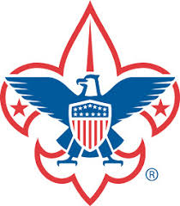

University of Scouting

Classes for Adult Leaders & Scouts BSA
ONLINE REGISTRATION Now OPEN
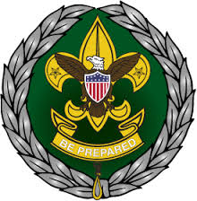
20+ EXCITING CLASSES TO CHOOSE FROM !

October 26, 2019 8am to 4pm
Church of Jesus Christ of Latter-day Saints
1219 Oak Knoll Rd.
Santa Maria, CA
Hosted by
Los Padres Council
Boy Scouts of America

