Pacific Coast District Camporee
April 12, 13, 14, 2019
Larsen’s Meadow, Rancho Alegre Scout Camp
“Be Like Bigfoot; Leave No Trace!”

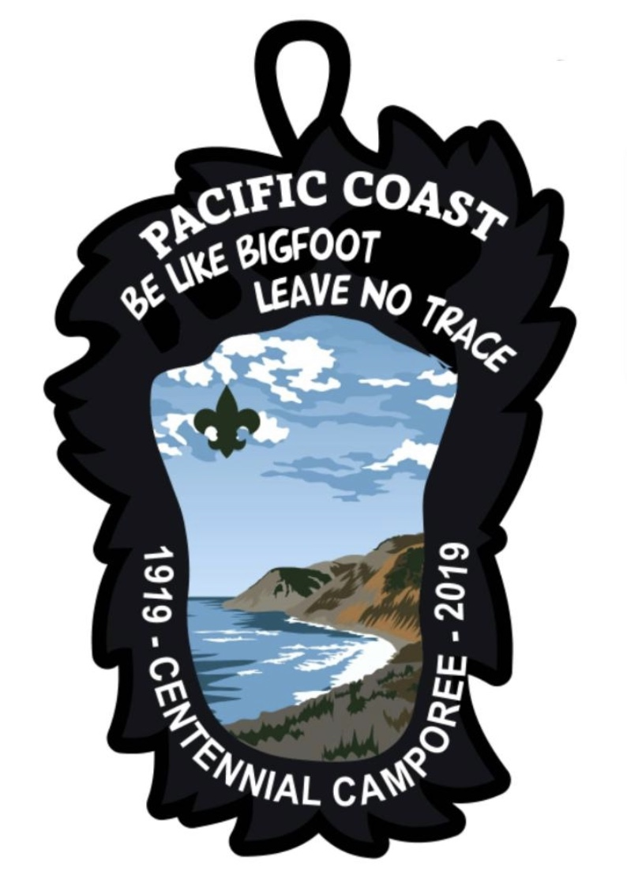

Table of Contents

Registration Form
What is a Camporee?
Daily Schedule & Camporee Events
Camporee Rules & Information
Event Score Sheet
Troop Campsite Inspection Score Sheet
Patrol Uniform Inspection Score Sheet

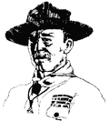

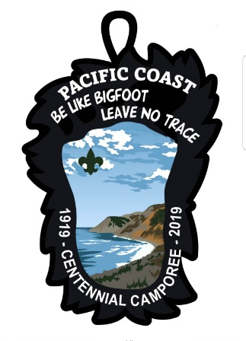
Pacific Coast Camporee 2019
Scouts BSA Registration Form
“Be Like Bigfoot; Leave No Trace”
Pacific Coast District
April 12-14, 2019
Larsen’s Meadow at Rancho Alegre, California

Registration Fees:
$15.00 per person on or before 3/29/19 or $20.00 per person after 3/29/19.
Late Fee: All registrations received after April 9th or on-site will be charged $25.00 per person.

Scoutmaster and Troop Committee: Please complete and return this registration form, and a check for the fees and return them to:
Checks made out to: Los Padres Council
Santa Maria Office Santa Barbara Office
228 Town Center East 4000 Modoc Rd.
Santa Maria, CA 93454 Santa Barbara, CA 93110

PLEASE return the completed forms and fees to your Scout Shop by Friday, March 29, 2019. Thank you!

Registration Form (TO BE COMPLETED BY EACH TROOP)
Unit Leader Name: ________________________________ Tel. No. ____________________
Troop/Team Unit Number: _______ Webelos & Cub Scouts (Sat. Visit Only) _______
 | Patrol Name | Number of  Scouts/Adults | Fee  per Person |  | Total
Adults | N/A |  | $ |  | $
Patrol 1 |  |  | $ |  | $
Patrol 2 |  |  | $ |  | $
Patrol 3 |  |  | $ |  | $
Patrol 4 |  |  | $ |  | $
Total Due: |  |  |  |  | $
Will your Troop attend the hot dog feast? |  |  |  | Yes ____ No ____
Will any members of your Troop attend the Saturday BBQ?  How many? ____ x $10 = $_____.00 |  |  |  | Yes ____ No ____

Council Use Area: Account #: 1-6801-101-20
Completed Registration Form and Fees Received? | Yes ____ No ____
Receipt Number: __________ Store Received: SM SB
Pacific Coast Camporee 2019
Webelos (Cub Scout) Registration Form
“Be Like Bigfoot; Leave No Trace”
Pacific Coast District
April 12-14, 2019
Larsen’s Meadow at Rancho Alegre, California

Registration Fees:
$15.00 per person on or before 3/29/19 or $8.00 per person for Saturday visit only.
Late Fee: All registrations received after April 9th or on-site will be charged $25.00 per person.

Cubmaster/Webelos Den Leader and Pack Committee: Please complete and return this registration form, and a check for the fees and return them to:
Checks made out to: Los Padres Council
Santa Maria Office Santa Barbara Office
228 Town Center East 4000 Modoc Rd.
Santa Maria, CA 93454 Santa Barbara, CA 93110

PLEASE return the completed forms and fees to your Scout Shop by Friday, March 29, 2019. Thank you!

Registration Form (TO BE COMPLETED BY EACH PACK)
Unit Leader Name: ________________________________ Tel. No. ____________________
Webelos (Sat. Visit Only) _______ Webelos (Camping & Sat.Visit) _______
$8.00/per person $15.00/per person
 | Den Name | Number of  Scouts/Adults | Fee  per Person |  | Total
Adults | N/A |  | $ |  | $
Den 1 |  |  | $ |  | $
Den 2 |  |  | $ |  | $
Den 3 |  |  | $ |  | $
Den 4 |  |  | $ |  | $
Total Due: |  |  |  |  | $
Will your Den attend the hot dog feast on Friday night? |  |  |  | Yes ____ No ____
Will any members of your Den attend the Saturday BBQ?  How many? ____ x $10 = $_____.00 |  |  |  | Yes ____ No ____

Council Use Area: Please attach the receipt to the forms and return to the DE. Account #: 1-6801-101-20
Completed Registration Form and Fees Received? | Yes ____ No ____
Receipt Number: __________ Store Received: SM SB
Pacific Coast District Camporee 2019
Camporee Guide

April 12, 13, 14, 2019
Larsen’s Meadow, Rancho Alegre Scout Camp
“Be Like Bigfoot; Leave No Trace!”

What is a Camporee?

A camporee is many things—an opportunity to live the Scout Oath and Law, camping fun for Scouts, the thumping of hundreds of feet on the way to an evening campfire, and the blue smoke from fires cooking stew or ham and eggs. It’s the patter of rain on many tents at night. It’s the ripple of wind-blown flags in the morning sun. It’s catching the idea of teamwork in your own patrol. It’s learning to carry out an order you don’t really like.

A camporee can be a perfect showplace for the Scouting program and, therefore, go far beyond a gathering of boys. It’s a perfect place to demonstrate the values of Scouting for both Scouts and Adults.

A camporee starts with the recognition that a patrol is the basic (camping) unit. The patrol demonstrates its very best camping techniques and shares its experiences with other patrols. The camporee involves the type of equipment that can be carried in a pack by boys and can be set up entirely by boys. The equipment thus set up enables the boys to be completely self-sufficient for a self-reliant experience over a period of two or three days.

Camporees are held on a council or district basis. They may be held at any time of the year. Camporee programs may include contests and demonstrations of outdoor Scouting skill as well as campfires, games, and field events. These activities show Scouting at its best.

Camporees can help councils and districts meet part of their goals. They stimulate overnight camping; they help units to attain part of the annual 10 days and nights of camping; and they help prepare units for long-term camping. Camporees thus help units to earn the Journey to Excellence Award.

Should you have any questions or concerns, please contact Joseph Knapp at Joseph.Knapp@securitasinc.com or April Wright-Litchfield at 478-9375 April.Wright@scouting.org.
Hope to see you there!!

Yours in Scouting,
The Pacific Coast District Camporee 2019 Committee

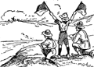

Pacific Coast District Camporee 2019
Daily Schedule
“Be Like Bigfoot; Leave No Trace!”
Friday, April 12
5:00 – 8:30 Check-In/Campsite Assignment & Set Up – Headquarters (Scout building)
6:30 – 7:30 Hot Dog Stand Open! BBQ area
8:30 – 9:00 Leader’s Meeting (Scoutmasters, Senior Patrol Leaders, and Event Leaders)
11:00 Taps/Lights out (all quiet in camp)

Saturday, April 13
7:00 Reveille
7:00 – 9:00 Breakfast Preparation/Breakfast/Cleanup
9:00 – 9:15 Morning Assembly, Flag Ceremony
9:15 – 9:45 Patrol Flag & Uniform Inspection
9:45 – 12:00 Begin Events/Campsite Inspections
12:00 – 1:30 Lunch Preparation/Lunch/Cleanup
1:30 – 4:30 Continue Events
4:30 Events End
4:30 – 5:30 Free time/Dutch Oven Cookoff Preparation
5:30 Dutch Oven Judging
6:30 Order of the Arrow Ice Cream Social (Please wear your sash)
5:30 – 7:30 Dinner Prep/Dinner/Cleanup (Tri-tip/chicken dinner for those who purchased tickets)
7:30 – 9:00 Campfire at the Campfire Bowl/Award Presentations/ (OA Callout)
9:00 – 11:00 Free time
11:00 Taps/Lights out (all quiet in camp)

Sunday, April 14
7:00 Reveille
7:00 – 9:00 Breakfast Preparation/Breakfast/Cleanup or Early Checkout
9:00 – 9:30 Interfaith Worship Service at the Campfire area
9:30 – 10:30 Breakdown Camp/Checkout (No checkout during the Interfaith Worship Service)

Camporee Events
Event No. | Event Name | Unit Sponsor | Event Leader
1 | Land Skis | Troop 41 | David Watkins
2 | Chariot Races | Troop 394 | TBD
3 | Toxic River Crossing | Troop 1 | Gary Heinemann and Graham Edney
4 | Hatchet Throwing | Troop 87 | Ron/Dan/Gene
5
6
7
8
9
10
11
12

Pacific Coast District Camporee 2019
Camporee Rules & Information
“Be Like Bigfoot, Leave No Trace!”

General Rules

1. All Scouts and adults shall obey the BSA rules and policies as stated in the Guide to Safe Scouting. All Scouts and adults shall obey the Scout Oath, Scout Law, The Outdoor Code and the following Camporee Rules.

2. All youth must be registered with the Boy Scouts of America.

3. Units must have two-deep adult leadership. All units should have on site their Annual Health and Medical Records for each Scout and Adult. Forms will be collected at Registration/Check-In and returned at Checkout.

4. Scoutmasters, Event Leaders and Senior Patrol Leaders: Please attend the Leader’s Meeting at 8:30 PM on Friday night.

5. Units are responsible for preparing their own meals (except for the hot dog meal on Friday night and optional $10 tri-tip/chicken dinner on Saturday night). All cooking must be done under adult supervision.

6. HOT DOG MEAL on Friday evening (please let us know on your registration if you are eating): Two hot dogs per registered Scout and adult will be provided (FREE) at the BBQ area between 6:30 to 7:30 on Friday evening (only). Veggie patties will also be available for those Scouts and Scouters who are vegetarian or vegan. We would like a unit or group to take the lead on cooking if interested.

7. Please, no “ringer” patrols. Troop leaders are requested to be ethical about composing their Patrols. Patrols competing in events must have a minimum of 4 Scouts and a maximum of 8 Scouts. Troops may combine patrols to create a provisional patrol to meet the minimum/maximum number of Scouts in a patrol. Patrols with less than 4 Scouts may participate in all events but won’t be included in the competition.

8. It’s OK to drive your vehicles and trailers to your campsite to drop off your gear. All vehicles & trailers must be parked in the designated parking area after unloading. RVs and camper trailers are not permitted due to space. Please park your vehicles in the parking lot facing in a direction you can drive forward to leave. Please let the Camporee Staff know if you plan to bring an equipment trailer so that we can plan accordingly.

9. The BSA prohibits the use of alcoholic beverages and controlled substances at any activity involving participation of youth members.

10. No Smoking. No firearms. No Pets.

11. Please no toys, electronic games, trading cards, comic books, radios, or MP3 players (or the like). No cell phones for Scouts. Adult leaders may have cell phones.

12. NO wandering from the Camporee area. You must not go beyond any fence lines at any time.

13. Please bring trash bags and pack out your garbage to the dumpsters unless otherwise requested. “Be Like Bigfoot, Leave No Trace!”

Pacific Coast District Camporee 2019 - Camporee Rules & Information (Continued)

14. Strain your dishwater, disposing of the strained material in a trash bag. Use the wide dispersal method (broadcast method) to dispose of dishwater. Please, no dishwashing in the restrooms.

15. All games like “Kill the guy with the ball” are prohibited. Scout leaders are requested to step in and stop these kinds of games if observed. Any open flames in tents are prohibited. All weapons, nuclear devices, ammunition, fireworks, bows & arrows, whips, explosives & harsh language are prohibited.

16. Any special rules & information will be announced at the Leader’s Meeting on Friday at 8:30 P.M.

17. If a fire alarm is sounded, gather up your Scouts and adults and meet in the parking lot.

Webelos:

1. Webelos Scouts are able to camp overnight at Camporee as long as they are accompanied by an adult and are camping with a Boy Scout Troop. Webelos Dens cannot register and camp without a Troop. Webelos are welcome and encouraged to visit the Camporee on Saturday and stay for the campfire on Saturday night!

2. Webelos may participate in Boy Scout events if the event leader determines that their participation will not interfere with Boy Scouts who need to complete these events to compete for their awards.

Recommendations:

1. Bring a shovel – Frequently helpful.

2. Please carpool as much as possible. There’s not a lot of parking space.

3. Bring everything you need including your patrol and group camping gear such as dining flys, lanterns, camp chairs, tents, and tables. Bring materials to build a gateway and other camp improvements. Drinking water is available.

4. Each Scout should bring their Basic Scout Essentials (especially a filled water bottle), personal camping gear, Totin’ Chip Card and Firem’n Chit Card.

5. Each patrol should carry 12 wooden matches, pocket knife, patrol first aid kit, at least one compass, paper and pencil, wrist watch, filled water bottle, and Scout spirit. Each patrol should bring one set of Scout Basic Essentials to the morning assembly – These will be inspected as part of the patrol uniform inspection!

Troop/Patrol Participation:

1. Troops will be requested to conduct a skit, a run-on, or sing or lead a song during the Camporee campfire on Saturday night. Keep them short and one per Patrol. Remember that we’re Scouts so keep these clean!!

Pacific Coast District Camporee 2019 - Camporee Rules & Information (Continued)

Check In Procedure:

1. Upon arrival, please have a leader from your troop check in at the headquarters to get your campsite assignment and Patrol Leader’s Card(s). Event leaders will receive event location assignments. DO NOT proceed to the camping area until you have checked in.

2. Please sign up for one of the troop good turn services, such as flag ceremony, latrine clean-up, etc.

Check Out Procedure:

1. Please police your campsite area and leave it better than when you arrived. “Be Like Bigfoot, Leave No Trace!”

2. Ask a member of the Camporee staff to check out your site before leaving. (Please, no check-out during the Interfaith Worship Service or during the Saturday night campfire). When you are given your Camporee patches, you are checked out! LDS troops may check out on Saturday night. (Remember your patches!).

Awards and Scoring:

1. Patrols will be scored by the Troop providing the event and awarded individually for Presidential, 1st, 2nd and 3rd place in events, the uniform inspection, and presidential award to the highest scoring patrols.

2. Troops are scored and awarded for Presidential, 1st, 2nd, and 3rd place for the combination of the campsite inspection, uniform inspection, gateway competition and the patrol with the highest overall score.

Other Stuff:

1. Assignment of campsites is on a first-come, first-served basis. We’ll do our best to accommodate your troop’s campsite needs.

2. The First Aid Station is located at the Headquarters Pavilion.

3. The Order of the Arrow may conduct a “call out” during the Saturday campfire. If you are an OA member, please come to the campfire wearing your OA sash. There will be an Ice cream Social for all OA members at 6:30 PM on Saturday night.

Event Leaders (Please attend the Leader’s Meeting at 8:30 PM on Friday night):

Pacific Coast District Camporee 2019 - Camporee Rules & Information (Continued)

1. Let us know at the registration table what type of location you’ll need for your event – we’ll do our best to accommodate you! (Example: large area, smaller area, etc.). WE NEED EVENTS!

2. If possible, your event should handle several patrols at the same time. If a line forms, Boy Scout patrols take precedence over visiting Webelos.

3. Event score sheets will be provided to the event leaders in headquarters pavilion after the opening ceremony. Event leaders are requested to present the award ribbons for their events at the Camporee campfire.

4. Please complete ALL the parts of the score sheet for EACH patrol participating in your event including the patrol names, patrol numbers and the name of your event!!

5. Please have a Scout or adult deliver the completed event score sheets to the headquarters pavilion during the day so we can input them to the tally sheet. Just ask if you need more score sheets!

Volunteers Conducting Campsite and Uniform Inspections:

1. Please attend a short meeting at the assembly area that will be conducted on Saturday at 8:30 AM just before the morning assembly. This meeting is to help prepare you to conduct the inspections!

2. Please read the inspection/score sheets before you inspect! These inspection/score sheets are updated (improved) each year!!

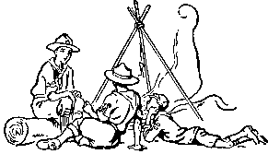

Pacific Coast District Camporee 2019
Event Score Sheet
“Be Like Bigfoot; Leave No Trace!”

Patrol Name:

Patrol No. Troop/Crew No.

Event Name:

Scored By:

Please score each patrol between zero (0) and the maximum allowed or anywhere in between for each category. If the category is not applicable to your event, then award the maximum points for that category. On the bottom, please enter the Total Points Earned!

 | Category |  | Possible Points |  | Points Earned
1 | Participation | Did they attempt to perform the event? | 0 to 10
2 | Knowledge | Did the patrol demonstrate knowledge of the skills required (if applicable)? | 0 to 10
3 | Prepared | Did they have the gear/equipment necessary to complete the task? | 0 to 10
4 | Teamwork | Did they cooperate? Did all the Scouts in the group participate in the event? | 0 to 10
5 | Communication | Did the patrol listen to the instructions and ask questions if they didn’t understand the task? | 0 to 5
6 | Planning | Did they stop and discuss the task?  Did they assign sub-tasks? | 0 to 5
7 | Patrol Spirit | Did they work together as a team and as a Scout patrol? Patrol flag? Patrol Yell? All in Uniform (Class A or Class B)*? | 0 to 10
8 | Patrol Leader | Was he in charge? Did he lead the group? Did they follow his lead? | 0 to 10
9 | Completion | Did they complete the task? If not, did they go down trying their best? | 0 to 30
Total Points Earned:
*A “Class B” Uniform is a troop or patrol T-shirt or polo shirt that the whole patrol wears.

NOTES TO THE SCORER:
(1) Briefly discuss the patrol’s performance with them. Tell them what they did well and what could be improved. Please turn in the completed score sheets to the Camporee scoring committee a few times during the day and the remainder at 4:30 PM. Thanks!!
(2) REMEMBER: ONLY COMPLETE THIS FORM IF THE PATROL CONSISTS OF FOUR TO EIGHT SCOUTS IN THE PATROL!!
Pacific Coast District Camporee 2019
Troop Campsite Inspection Score Sheet
“Be Like Bigfoot; Leave No Trace!”

Troop/Crew No.

Please score the troop/team between zero (0) to the maximum allowed or anywhere in between for each category. On the bottom, please enter the Total Points Earned!

 | Category | Possible Points | Points Earned
1 | Tents: Properly set up for the type of tent (fabric taut and neat, tent flys set up or neatly folded and put away, all poles used, guy lines adjusted correctly, tents staked, flaps/doors/windows uniformly open or closed - if open, then flaps and doors must be tied back). Tent floor clean. | 0 to 20
2 | Personal Equipment: Sleeping bags arranged neatly on cots/ mattresses/foam pads or rolled up or hung neatly on outside line for airing. Clothing and gear neatly arranged or put away. Gear protected if bad weather (off the ground, away from tent walls). Wet towels hung up on outside line to dry or in a waterproof bag. NO food, radios, or other unapproved items inside tent. | 0 to 20
3 | Scout Method of Camping: Camp layout is thoughtful, neat, and organized. Camp schedule, duty rosters for each patrol, and fireguard plan are displayed. U.S. Flag and troop flag properly displayed (weather permitting). Camp improvements are evident, creative, and useful. Evidence of patrol method in use, e.g., tents grouped. Respect shown for camp property, troop equipment, and neighboring campsites. | 0 to 20
4 | Safety & Sanitation: Fires, stoves, and lanterns attended or dead out. No open flames in or near tents. Fire buckets at least ¾ full of fresh water and critter sticks. Equipment (axes, saws, knives, etc.) stored and used safely and properly. Main traffic areas clear of tripping/head hazards. Trash picked up and bagged. Food put away and stored properly. Tables and grounds clean of food and spills. | 0 to 20
5 | Conservation & Stewardship: Low impact camping practices in use. No digging, ditching or evidence of fresh cutting or defacing of live trees or bushes. Campsite appearance is neat, but natural (Not raked clean) (No rock edging on along paths). No evidence of fresh defacing of tables or buildings. Waste water disposed of as to minimize impact and as not to pollute nearby water sources. | 0 to 20

Total Points Earned:

Please note: Campsite Gateways will be scored separately from the campsite inspection. Ribbons will be given to the Troop with the best Gateway.

Pacific Coast District Camporee 2019
Patrol Uniform Inspection Score Sheet
“Be Like Bigfoot; Leave No Trace!”

Patrol Name:

Patrol No. Troop/Crew No.
Please score each patrol between zero (0) to the maximum allowed or anywhere in between (except for patrol flag) for each category. On the bottom, please enter the Total Points Earned. The categories reflect the complete official uniform. However, the troop can authorize certain options. If necessary, check with the Scoutmaster if you need to confirm troop uniform policy.
 | Category (Note: Both new and old-style uniforms are OK!) | Possible Points | Points Earned
1 | Good posture, clean face and hands, and hair combed – don’t penalize for Scouts wearing beards. | 0 to 5
2 | Troop hat (worn properly) & neckerchief (per troop policy) | 0 to 5
3 | Official Scout shirt (tucked in, clean and in good repair) | 0 to 10
4 | Epaulets, American Flag, Council Shoulder Patch, Troop Numerals, World Crest (sewn or at least tacked on properly) | 0 to 19
5 | Journey to Excellence Award (all or none should wear award – if worn, all should wear the same year of award) | 0 to 5
6 | Patrol badge (all should be wearing one – don’t penalize provisional patrols which may be wearing different badges) | 0 to 5
7 | Badge of rank (Unless they have not reached rank yet) | 0 to 5
8 | Neckerchief Slide (official or Scout made – uniformity not required) (if a rubber band is used, reduce score by 5 points) | -5 to 10
9 | Official belt & buckle (worn properly) | 0 to 5
10 | Official Scout trousers or shorts (jeans or other pants are OK if authorized by the troop and as long as there is uniformity) | 0 to 5
11 | Official Scout socks | 0 to 1
12 | Scout Outdoor Essentials (One set per Patrol): Pocketknife, first aid kit, filled water bottle, flashlight, matches, fire starters, sun protection, and compass. | 0 to 10
13 | Uniformity of patrol (Provisional patrol are OK) | 0 to 5
14 | Wearing of any unauthorized patches, pins, or badges | -5 to 0
15 | Patrol flag on a staff – Any style (If they have a patrol flag on a staff, then award 10 points. If none, then award 0 points) | 0 OR 10

Total Points Earned:

Pacific Coast District Camporee 2019
Gateway Inspection Score Sheet
“Be Like Bigfoot; Leave No Trace!”

Troop/Crew No.

Please score the troop/crew between zero (0) to the maximum allowed or anywhere in between for each category. On the bottom, please enter the Total Points Earned!

 | Category | Possible Points | Points Earned
1 | Flags:  Incorporates the U.S. Flag, unit flag, and/or patrol flags. Are the flags properly displayed? Are the flags in good condition, not torn, faded, or soiled? | 0 to 20
2 | Gateway Design:  Was the camporee theme, “Be Like Bigfoot; Leave No Trace” incorporated into the design? Is the gateway free-standing? Was a sign included? | 0 to 20
3 | Knots and Lashings:  Correct use of knots and lashings? All rope ends whipped, fused, or back spliced? Were a variety of knots and lashings used properly? | 0 to 20
4 | Creativity & Originality:  How complex was the design? Was the design original? What is the overall appearance like? Neat and sturdy or haphazardly thrown together? | 0 to 20
5 | Gateway Construction:  Appropriate dimensions to comfortably allow for entry and egress? Are the Gateways safe and sturdy? Did the Scouts and their youth leaders guide and construct the gateway? | 0 to 20

Total Points Earned:

Pacific Coast District Camporee 2019
Cantin Memorial Dutch Oven Cook-off Score Sheet
“Be Like Bigfoot; Leave No Trace!”

Troop/Crew No.

Please score the troop/crew between zero (0) to the maximum allowed or anywhere in between for each category. On the bottom, please enter the Total Points Earned!

 | Category | Possible Points | Points Earned
1 | Teamwork | 0 to 10
2 | Presentation | 0 to 10
3 | Taste | 0 to 10
4 | Aroma | 0 to 10
5 | Desire for seconds | 0 to 10
6 | Creativity | 0 to 10

Max 60 points
Total Points Earned:

