Arrowwood District
Leader’s Guide
Fall Camporee 2024
Wild-Wild West
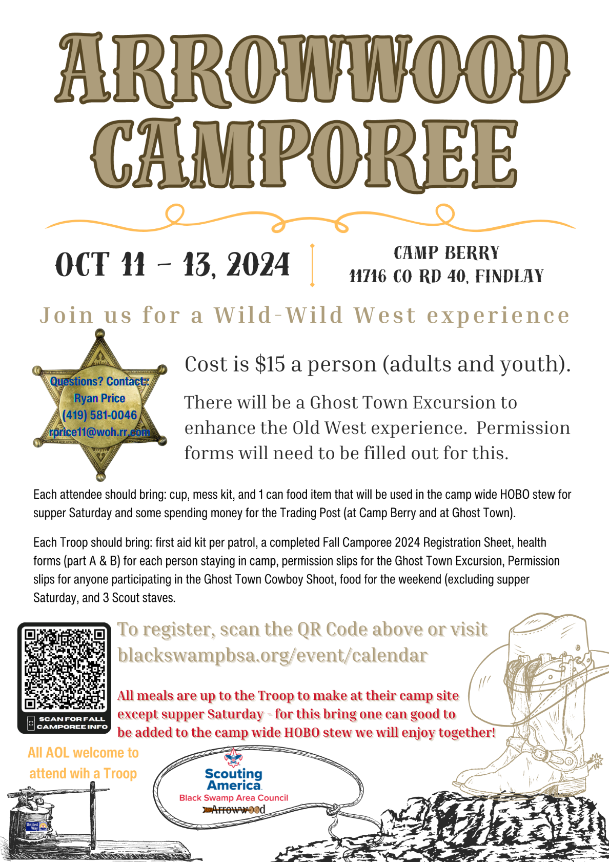

Wild-Wild West
WHAT IS A Camporee?
A camporee is an event that Scouts from many troops come together for entertainment, competition, fun, fellowship, learning and/or service. They are usually held in Spring and Fall, and sometimes in the Summer. Most often, they are centered around patrol level events.
Wild-Wild West:
Scouts will participate as a patrol, with up to eight Scouts, using various skills of the old west to score points. Scouts BSA and Arrow of Lights working on the Patrol Method can attend this event.
WHEN AND WHERE?
The 2024 Arrowwood District Fall Camporee will be held on October 11, 12, and 13 at Camp Berry. Check-in will be Friday evening after 5pm. Saturday Morning Flag at 0800 all participants must be signed in by this time for those units not coming Friday night.
FEE AND CHECK-IN PROCEDURE:
The fee is $15.00 per Scout. 1 canned good will be required for the Saturday Evening Round up Meal (Hobo Stew). Registered troops will receive 2 free complimentary patches for leaders. Additional patches may be purchased in the Troop Admin Area, if stock allows. Please make checks payable to the Black Swamp Area Council, Boy Scouts of America. If the Camporee is postponed and your unit is unable to attend the alternate date, your preregistration fees will be refunded to you. Upon arrival at Camp Berry, proceed to the parking lot as directed. Only special vehicle passes will be allowed outside the parking area (this is for safety reasons.) Patrols should stay together in the parking lot while the Patrol Leader(s) and Unit Leader go to the Troop Admin Area (Howard Lodge) for check-in. As part of the registration process, the attached registration roster is to be filled out ahead of time and turned in. The Personal Health and Medical Record for each participant MUST be turned in at the time of registration to the First Aid Attendant (Physician’s signature is not required). These forms should be picked up prior to your unit’s departure. Units will then be released to their Campsite to set-up. At 8pm there will be an SPL & Scoutmaster Cracker Barrow/meeting at Howard Lodge. At this meeting, Permission Slips will be collected for those Scouts participating in the Ghost Town Excursion. Keep in Mind that an Additional permission slip will need to be completed by a parent of a scout participating in the Cowboy Shoot at Ghost Town. It is also to be understood that a Scouts Parent MUST be present and standing beside them as they shoot at the Cowboy Shoot. ITS STATE LAW!
PREPARING TO START:
The Patrols will receive their scorecards and maps at the Starting Line (O.K. Corral). Patrols will have plenty of time to go through each station. Each Station is a first come first served basis. Scoring will be on the patrol level and will be tallied and compared to the other patrols at the end of the event.
Wild-Wild West Camporee EVENTS:
In preparation for the Camporee, inform all participating patrols that all events require basic Scouting skills found in the Boy Scout Handbook. The Scout Oath and Law will be the policy at all areas and on the trails Patrols entering an Off-Limits area will be disqualified from the Derby.
Friday Evening—Check-in Admin ( Howard Lodge)
Friday 8pm SPL Meeting, Cracker Barrow ( Howard Lodge)
Saturday Morning Flag 8 AM
Saturday AM events 8:30 AM to Noon
Saturday Lunch Noon to 1:30 PM (at Troop campsites)
Saturday PM events 1:30- 4:00 PM
Saturday 4PM to 5PM Free Time and Prep for Transport to Ghost Town
Saturday 5:00-5:30PM Shuttle to Ghost Town
Saturday 5:30-7:30 PM Ghost Town Exploration
Saturday 7:30 Shuttle Back to Camp Berry Hobo Stew at the O.K. Corral
Saturday 9pm Closing Campfire
Saturday 10 PM Release units back to Troop Sites
Sunday Morning 8 AM Troops begin Check-out Process per Camp Berry Policies
*Schedule subject to change

HOW WILL THE SCORING BE DONE?
Your final score will depend on how well your team works the problems and how soon you finish the race. At each city the patrol will be given a score, from 20 to 100, based on how well they complete the activity. Additional guidance on scoring and awards will be the SPL/ Scoutmaster Cracker Barrow/ Meeting Friday Night at 8PM in Howard Lodge.
FOOD FOR THE CAMPOREE:
Meals will be conducted at the troop level, at Troop Sites, except for the Saturday Evening Round-up. Each person will be required to bring one canned good for HOBO Stew. These canned goods will be collected at the SPL Meeting Friday evening or upon check-in Saturday morning. Troops are encouraged to bring a dessert to share for the Round-up meal. The Location of the Round-up meal will be Boyd Pavilion. This will take place upon return from Ghost Town ( around 7:30 pm). Mess-kit and cup will be required. Breakfast will be up to the troop before flag on Saturday morning. Lunch will be from noon until 1:30 pm on Saturday at the Troops campsite.
AWARDS/CLOSING CEREMONY
- Each Scout will receive an official Wild-Wild West Camporee patch.
- Awards for the top 3 place Patrols will be handed out either at Ghost Town or the closing campfire.
VISITORS
Visitors are welcome and encouraged to attend the Camporee. Because of its high visibility, this event is an excellent opportunity for parents, Arrow of Light Scouts and interested citizens to see Scouting in action. Visitors are welcome to visit the Wild-Wild West and Ghost Town. Visitors, including Scout Leaders and Scouts, are to be in the registration area only on official business.
Visitors will be required to check in at Howard Lodge. Non- registered Visitors will not be permitted to spend the night. Parents of scouts who will be shooting at the Cowboy Shoot in Ghost Town may meet at Camp Berry or at Ghost Town. Troops will be responsible for their scouts at the Cowboy Shoot, ensuring that their parent is present when they are ready to shoot.

CONDUCT
The Scout Oath and Law will be the rule of the Camporee, as in any Scouting event. While on their own going from area to area and while going to and from Ghost Town, the Patrols should follow the rules of outdoor conduct and the principles of Scouting No Patrol flags are to be stolen, violated, or damaged – perpetrators will be disqualified. There may be situations that arise in the event areas or other locations of the Camporee where decisions must be made which are not covered in this guidebook; these decisions will be made by the members of the Camporee Committee and will be final.
Refunds:
Cancellation Policy
GENERAL INFORMATION PERTAINING TO ALL REFUNDS No refunds will be issued for activities where promotion literature states No refunds Deposits are non-refundable. All monies are refundable if the council or district cancels an event. Refund requests for rescheduled events due to weather conditions will be dealt with on an individual basis, partial refunds can be granted after incurred expenses for the event have been taken into consideration. Transferring fees from one person to another within the same unit for the same program is permissible. Fees are not transferable from one event to another. No refund request for any event or facility will be accepted more than 14 days after the conclusion of the event. For resident camps, each session or week is considered a separate event. Any refund granted will be credited back to the source of the original payment. i.e., Credit card back to credit card, check back to checking account, etc. Valid reasons for requesting a refund include: Illness Death in family, or Change in business plans. In no event shall any refund be made for any reason if the cost of the event has not been completely met. If substitution for participation in the event has been secured, then full refund may be made to the individual originally registered. Any refunds granted will be reduced by the cost of any deposit plus the cost of any materials already procured. Refunds will not be made for late arrivals or early departures. All requests for refunds of money must be made in writing to the Black Swamp Area Council, Boy Scouts of America. Supporting receipts must accompany the request.

Health & Safety:
Troops must have their Troop First Aid Kits readily available at their campsite. Patrols must carry their Patrol First Aid Kit with them at all times. Camp Berry public address and sirens will be utilized to inform participants of inclement weather. Inclement weather gathering spot will be Donnell Lodge. All accidents and or injuries must be reported to the Health Officer. The Health Lodge will be open in Yammine Lodge for needed first aid treatment.

Needed Equipment:
Each scout will need their essential equipment per Scout Handbook.
Cup
Mess kit
Patrol needs: 3 scout staves, patrol first aid kit.

Ghost Town Excursion:
The Owners of Ghost Town, down the road from Camp Berry, are extending their hours of operation on Saturday, October 12, 2024 for an exclusive Old West Experience for our camporee participants. We will begin shuttling scouts to ghost town from Camp Berry between 5 and 5:30 PM. We will begin shuttling back to Camp Berry at 7:30 PM. Cowboy Shoot at Ghost Town will be first come first serve as there may be limited spots for participants given our limited time. All buildings and trading post will be open at Ghost Town. Participants may want some spending money for Ghost Town’s Trading Post. Further, A parent is required to be standing next to their child during shooting at Ghost Town per Ohio State Law. There will be a permission slip that needs to be completed for all scouts going to the Ghost Town Excursion. In addition, there will be another Permission slip for participants of the Cowboy Shoot at Ghost Town.

Arrowwood Fall Camporee
2024 Registration Sheet
Scoutmaster/Crew Advisor – Please fill out and present this form to Camporee Admin at Camp Berry upon check in. Please print in ink.
Troop/Crew # __________ District ______________________________ Town _________________________ Scoutmaster/Advisor Name_________________________________________________________________ Number of Patrols ________________Total Scouts Participating _____________ Adults ______________ (Please put emergency phone numbers after each Scout’s name)
Patrol Name___________________________
1.____________________________________ 2.____________________________________ 3.____________________________________ 4.____________________________________ 5.____________________________________ 6.____________________________________ 7.____________________________________ 8.____________________________________
Patrol Name___________________________
1.____________________________________ 2.____________________________________ 3.____________________________________ 4.____________________________________ 5.____________________________________ 6.____________________________________ 7.____________________________________ 8.____________________________________
Patrol Name___________________________
1.____________________________________ 2.____________________________________ 3.____________________________________ 4.____________________________________ 5.____________________________________ 6.____________________________________ 7.____________________________________ 8.____________________________________
For Official Use Only: Pre-registration fees: _____________ Walk-In fees: ___________________
Total Fees: _____________________ Check # ___________ Amount # ____________
Cash Payment #__________________________________________________________________________

Permission Slips:
A permission form must be completed by a parent or guardian of any youth wishing to attend the Camporee and Ghost Town Excursion/Cowboy Shoot. The form must be completed and signed by check in.
Please note that we will make every effort to allow as many people as possible to enjoy the cowboy shoot. However, time is a limiting factor for this activity and thus may exclude some individuals. This will be a first come first served basis.

Arrowood Fall Camporee Permission Slip

Name of Participant: ________________________________________________________________________
Birth Date: _______________________________ Age during activity: ________________________________
Address: ___________________________________________________________________________________
Has approval to participate in: Arrowwood Fall Camporee and Ghost Town Excursion/Cowboy Shoot on 10/12/2024: _______________ (please initial) OR
Has approval to participate in: Arrowwood Fall Camporee Only: ______________ (please initial)
I understand that participation in Scouting activities involves the risk of personal injury, including death, due to the physical, mental, and emotional challenges in the activities offered. Information about those activities may be obtained from the venue, activity coordinators, or local council. I also understand that participation in these activities is entirely voluntary and requires participants to follow instructions and abide by all applicable rules and the standards of conduct. In case of an emergency involving my child, I understand that efforts will be made to contact me. In the event I cannot be reached, permission is hereby given to the medical provider to secure proper treatment, including hospitalization, anesthesia, surgery, or injections of medication for my child. Medical providers are authorized to disclose protected health information to the adult in charge and/ or any physician or health care provider involved in providing medical care to the participant. Protected Health Information/Confidential Health Information (PHI/CHI) under the Standards for Privacy of Individually Identifiable Health Information, 45 C.F.R. §§160.103, 164.501, etc. seq., as amended from time to time, includes examination findings, test results, and treatment provided for purposes of medical evaluation of the participant, follow-up and communication with the participant’s parents or guardian, and/or determination of the participant’s ability to continue in the program activities. With appreciation of the dangers and risks associated with programs and activities including preparations for and transportation to and from the activity, on my own behalf and/or on behalf of my child, I hereby fully and completely release and waive any and all claims for personal injury, death, or loss that may arise against the Boy Scouts of America, the local council, the activity coordinators, and all employees, volunteers, related parties, or other organizations associated with any program or activity. NOTE: The Boy Scouts of America and local councils cannot continually monitor compliance of program participants, or any limitations imposed upon them by parents or medical providers. List any restrictions imposed on a child participant in connection with programs or activities below and counsel your child to comply with those restrictions. List participant restrictions, if any: _______________________________________________
Photos of my Scout may be used in promotional material: Yes _________ No _________
Participant Signature ___________________________________________ Date________________________
Parent Printed Name ________________________________________________________________________
Parent Signature ____________________________________________________________________________
Date _____________________

